
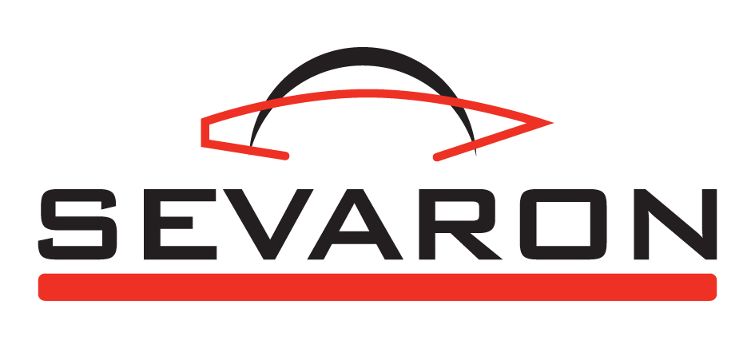
Laboratory diagnostics – Dogs
Diagnostic Laboratory of the company SEVARON PORADENSTVÍ, s.r.o. has been performing diagnostics of small animals since 2005. In 2007 it was accredited by the Czech Accreditation Institute. In 2009 the Diagnostic Laboratory extends canine diagnostics by a number of serological examinations and the Real Time PCR.

1. Microbiological examinations

- Aggregatibacter aphrophilus
- Bacillus cereus
- Bordetella bronchiseptica
- Campylobacter spp. (C. jejuni)
- Clostridium spp. (C.perfringens, C. difficile)
- Corynebacterium spp.
- Escherichia coli, haemolytic E. coli
- Haemophilus heamoglobinophilus
- Klebsiella pneumoniae
- Listeria monocytogenes
- Pasteurella spp. (P. multocida, P. canis)
- Pseudomonas aeruginosa
- Proteus spp. (P. mirabilis, P. vulgaris)
- Salmonella spp.
- Staphylococcus spp. (S. aureus, S. intermedius)
- Streptococcus spp. (S. canis)

We perform determination of sensitivity to antibiotics for individual pathogens.

2. Serological examinations
Immunochromatographic tests ELISA

- Borrelia burgdorferi  - Brucella  - Coronavirus, Rotavirus  - cPL (pancreatic lipase)  - CRP (C–reactive protein)  - Dirofilaria immitis  - Ehrlichia canis | - Giardia intestinalis  - Chlamydophila felis  - Influenza  - Leishmania  - Parvovirus  - Relaxin  - Rheumatoid factor | - Chlamydophila spp.  - Leptospira spp.  - Nt-proBNP  - proANP  - Neospora caninum  - Toxoplasma gondii

3. PCR examination (Real Time PCR) 4. Others
- Borrelia spp.  - Coxiella burnetii  - Chlamydophila spp.  - Leptospira spp.  - Neospora caninum  - Toxoplasma gondii |  | - Babesia canis, Babesia gibsonii  - Biochemistry  - Parasitology  - Pathologic-anatomic examination  - Histology

Sample transportation: close the sample thoroughly, pack into watertight material and place into a box or into a bubble envelope together with the dully filled-in order form, send as ordinary consignment or by EMS.

Term of examination
- MICROBIOLOGY – depending on pathogen complexity, incl. determination of sensitivity to ATB 3 – 5 days
- IMMUNOCHROMATOGRAPHIC TESTS 1 day
- SEROLOGY, Real Time PCR, PARASITOLOGY 7 days

Sample acceptance: Mo – Fri 7:00am till 7:00pm, in extraordinary cases as agreed by phone

Form of result sending: e-mail message, SMS message, facsimile, by post incl. the invoice

Speed, quality, discretion and help to the animal patients are the most important principles of our laboratory.

Further information and pricelist of the laboratory diagnostics - see www.sevaron.cz

Contact: Mgr. Dita Kellnerová, tel: 777 714 157; laborator@sevaron.cz

